|  |
| --- |
| Solar Sense Node |

|  |  |  |
| --- | --- | --- |
| IV-Curve group |  |  |
| Alireza Eskandari  Email: ali03es@gmail.com | Tel: 09184796877  University of Tehran - Tehran |  |

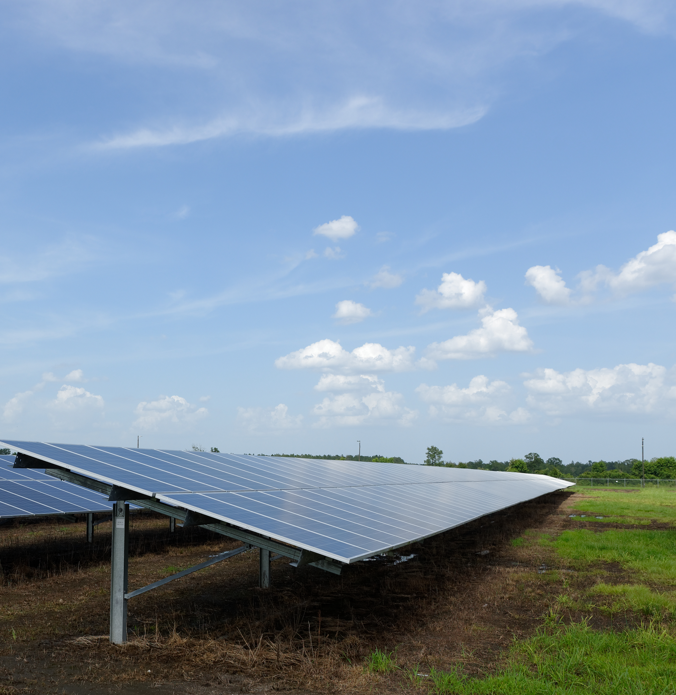

# ****Design SPECIFICATIONS****

1. Battery powered
2. Fully portable
3. Battery life 8 hours or longer
4. The ability to measure solar panel temperature
5. The ability to measure solar panel inclination
6. The ability to measure solar irradiance
7. Transmit telemetry data to the main device or a computer
8. Wireless link range 100 meters or greater

|  |  |  |
| --- | --- | --- |
| Spec | Solar 03 | Proposed solution |
| Battery life | 24hours | 30hours or higher |
| Tilt angle range & accuracy | 1˚-90˚ ±(1.0% + 1°) | 1˚-90˚ ±1˚ |
| Module temperature range & accuracy | -40.0°C -99.9°C ±(1.0% + 1°C) | -55°C to +125°C ±0.5°C |
| Irradiance sensor range & accuracy | 0-1400 $\frac{W}{m^{2}}$ ±(1.0% + 3dgt) | To be determined |

The following report illustrates the different parts of the project and why each one was selected.

In addition to the information presented in this document, the link to the GitHub page of the project can be found [here](https://github.com/Alireza255/solar_sense_node) and below.

[github.com/Alireza255/solar_sense_node](https://github.com/Alireza255/solar_sense_node)

## Choosing a box

The sensor box, being a portable device, requires a box with a form factor that suits the portable nature of the device.

The proposed box after careful research can be seen in the picture below:

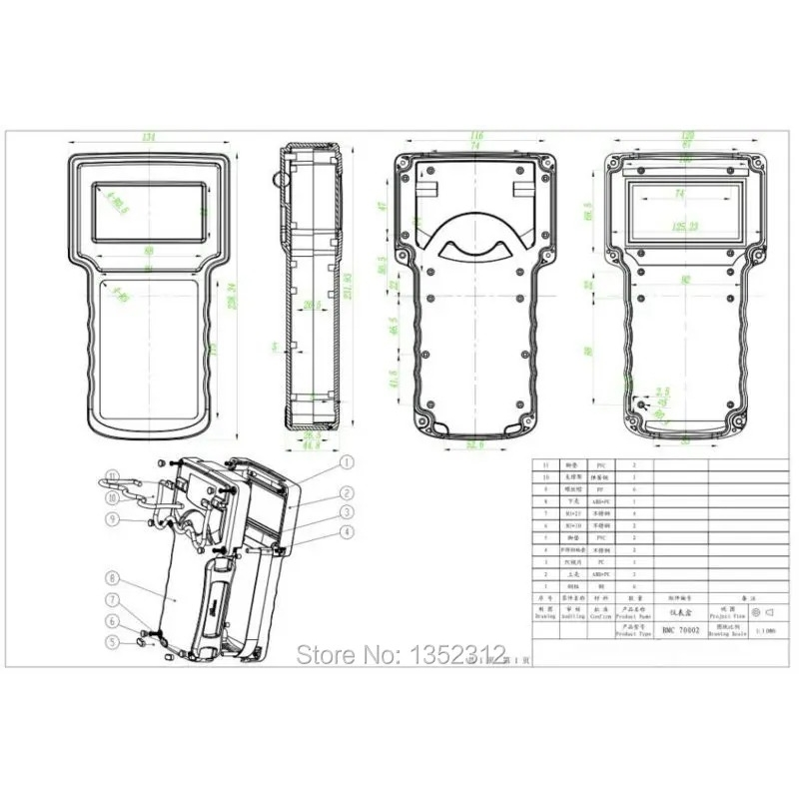

Mechanical specifications:

* Material: ABS plastic
* Overall dimensions: 238 × 134 × 58 mm
* Weight: 310 g (excluding screws)
* Front panel cutout size: 88 × 44 mm

The ability to implement a screen and also buttons for user interface. There are also designated flat spots on the top and bottom for mounting connectors.

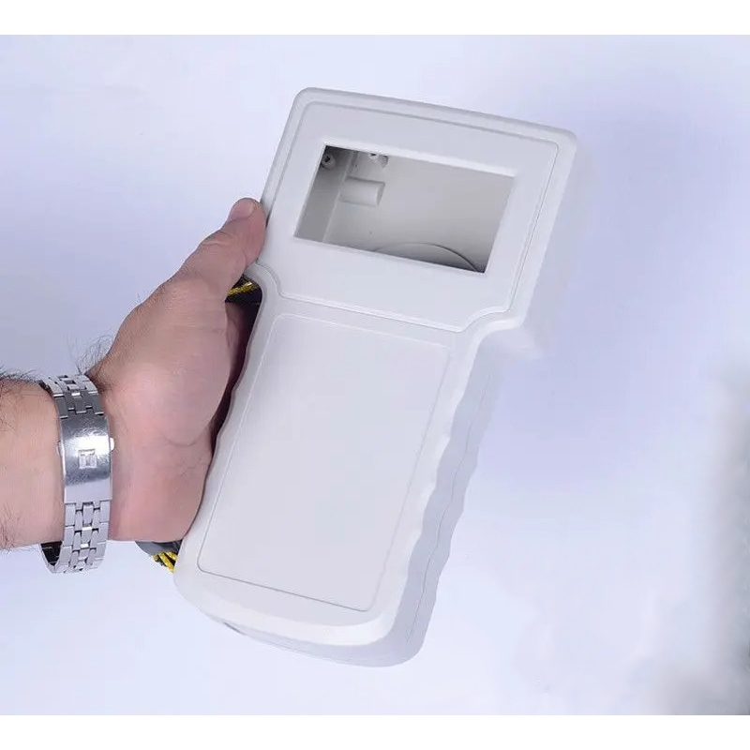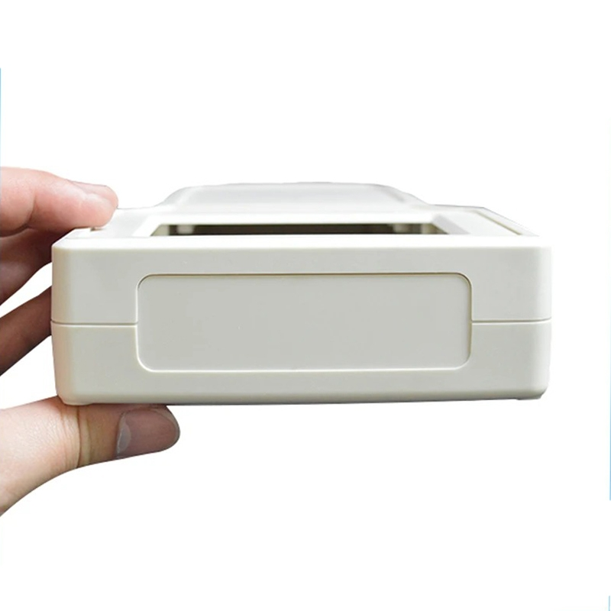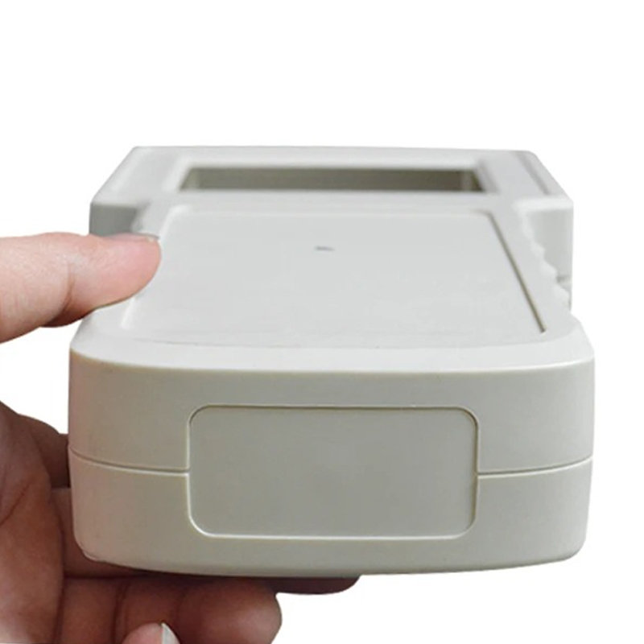

## Choosing a wireless link

After careful consideration of the constraints and available options. LoRa was chosen for communication between the sensor box and the main box.

Why LoRa Was Selected

The sensor box system is battery powered and requires **maximum wireless range and high reliability under all environmental conditions**. LoRa was selected because it provides **exceptional range** while operating at very low power levels. Using chirp spread spectrum modulation, LoRa maintains reliable communication over long distances, including non-line-of-sight and interference-prone environments.

Unlike short-range technologies, LoRa is optimized for **low data rate, low duty-cycle sensor applications**, allowing long battery life without sacrificing range.

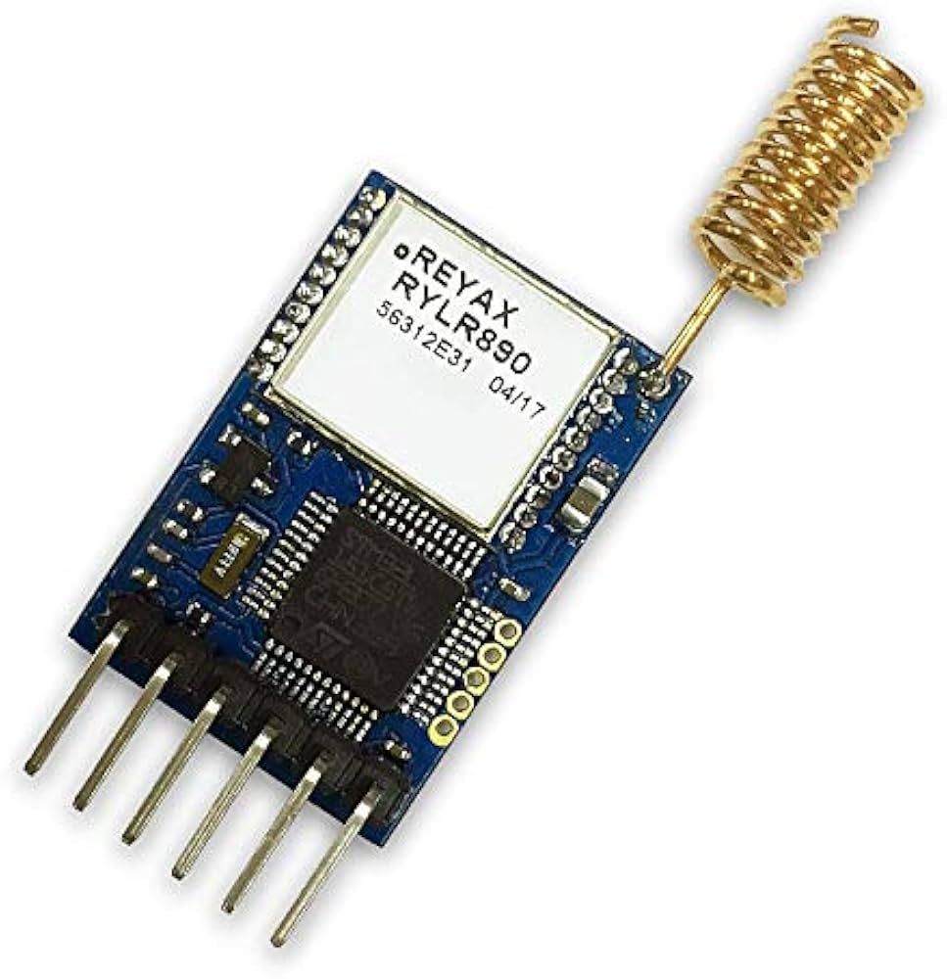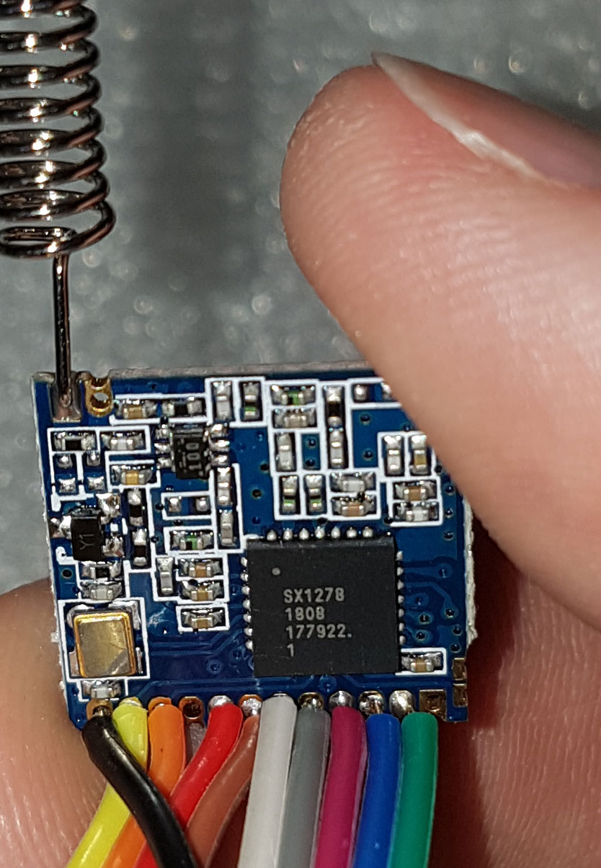

A comparison is made in the following table to illustrate the differences between the different communication links that are available for this application and why LoRa is the best for our application.

|  |  |  |  |  |
| --- | --- | --- | --- | --- |
| Technology | Typical Range | Power Consumption | Data Rate | Notes |
| LoRa | **500m–15 km** | **Very Low** | **Very Low** | **High link budget, robust in harsh environments** |
| Bluetooth | 10–100 m | Very Low | Medium | Short range, sensitive to obstacles |
| Zigbee | 50–200 m | Low | Low | Mesh required for long range |
| Wi-Fi | 50–100 m | High | High | Not suitable for battery operation |
| Sub-GHz FSK | 300–1000 m | Low–Medium | Low | Lower sensitivity than LoRa |
| Cellular | km+ | Medium–High | Medium | Requires SIM and network dependent |

It is important to note that the low data rate of the LoRa protocol will never be an issue because the amount of data that needs to be transmitted is extremely small.

## Choosing a microcontroller

ARM microcontrollers, specifically those from ST-Microelectronics are very well suited for portable applications due to their low power requirements. Another reason being that ST offers a wide range of different microcontrollers (MCUs) for almost any application.

Research by the author indicates that microcontrollers with built-in radio links exist and considering the requirements of the project, **STM32WLE5CCU6** stands out as the perfect choice as it includes LoRa out of the box.

This eliminates the need to add a different module on the board, simplifying the design and freeing up more room for other components.

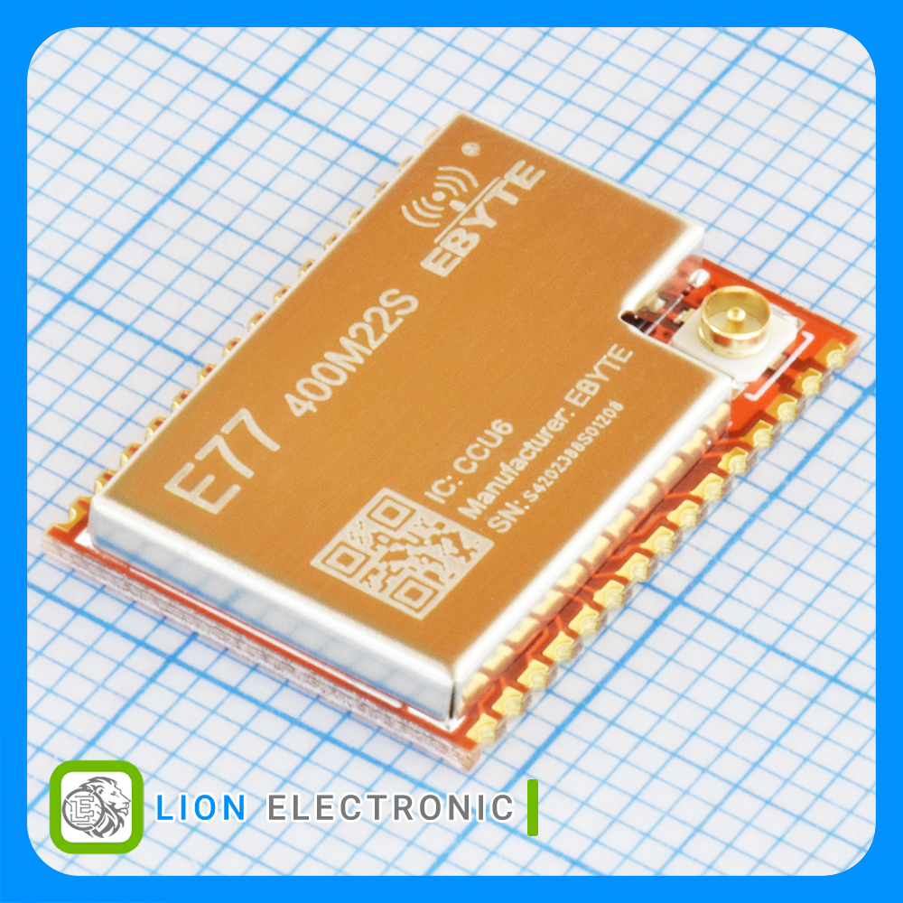Ready-made modules are available which already include everything that is needed to run the microcontroller.

This will greatly simplify the design process.

Communication Antenna

Any radio link needs an antenna and LoRa is no exception. In general, two different types of antennae are suitable for our application, both of which can be seen in the figures below.

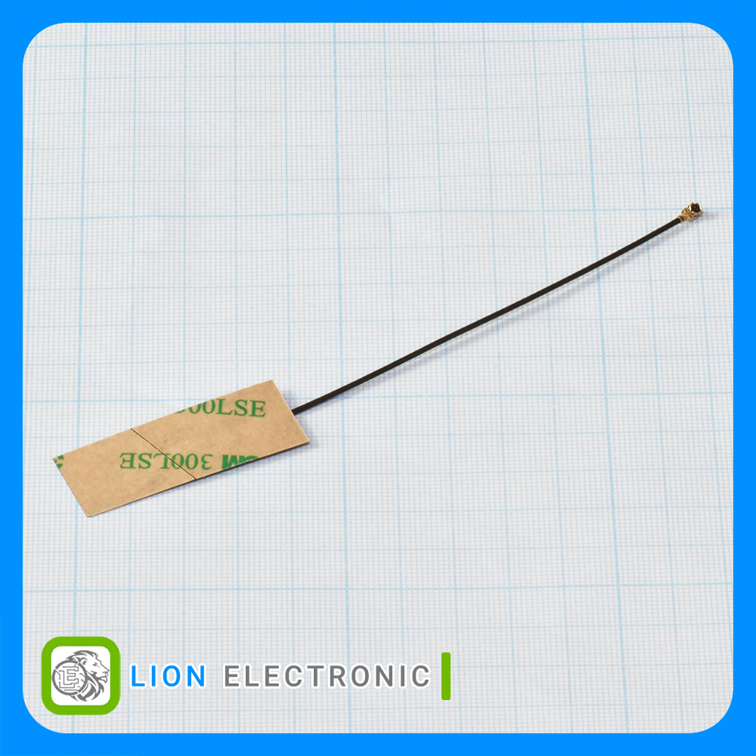 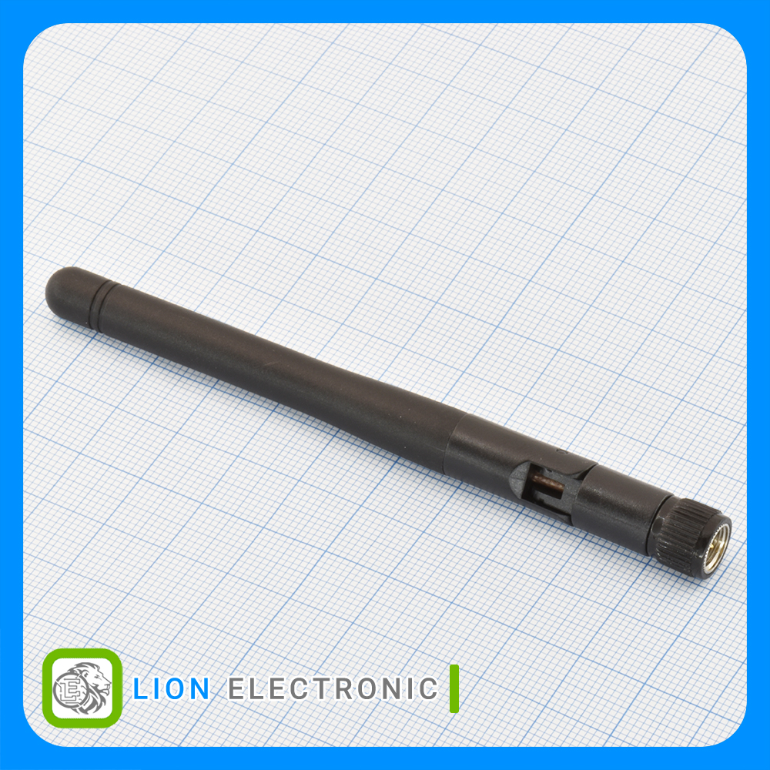

The antenna on the left is a patch antenna which can be installed within the device encloser itself while the antenna on the right is a monopole antenna. Both designed for 433MHz.

One drawback to the patch antenna is directionality. Which tends to be more focused in patch antennae. This makes communication harder since the orientation of the transmitter and reciver in relation to one another might not be ideal.

* While the benfit of the patch antenna is clear, testing with both antenna might be required in order to determine if the patch antenna is sufficient or not.

## Power supply

In order to increase efficiency and improve battery life, great emphasis was put on having only one supply rail in the entire device and since the MCU, wireless link and most of the other components are powered by 3.3V, a decision was made from the very start to choose the remaining components in such a way that they will also be powered from 3.3V.

Regulating the battery voltage down to 3.3V using a linear regulator was chosen because of its simplicity and also the absence of much benefits if the design was to use a switching regulator.

Choosing the right regulator required careful consideration of multiple factors, one of them being the quiescent current which is a measure of the current draw when the output current of the regulator is zero. This is extremely important as a low current draw when the micro controller is in sleep mode will mean a higher battery life when the device is not in use.

Now a question might arise; Why not just use a switch to allow the user to turn off the device?

The answer lies in the real-time-clock of the microcontroller, which keeps time and date at the expense of a few uA of current. Safe to say it is completely worth it.

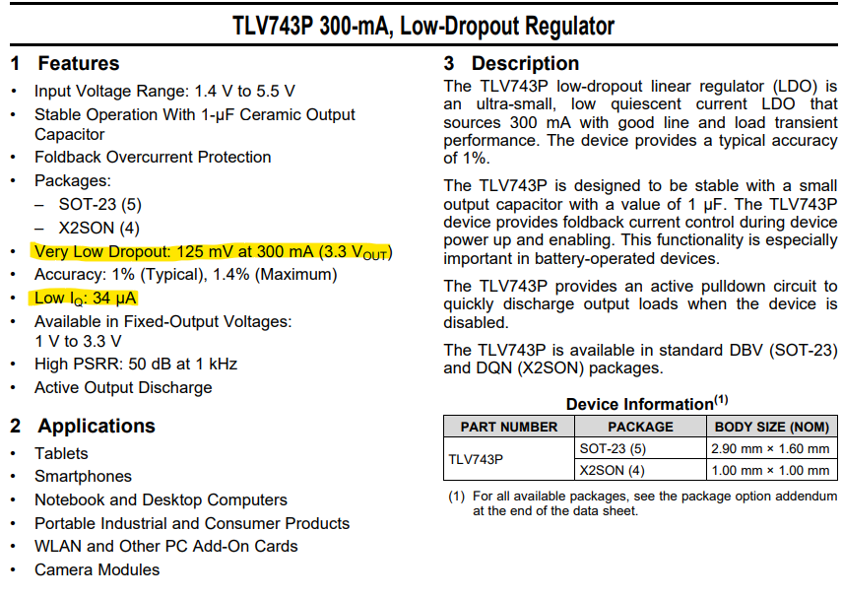

The chosen regulator can be seen on the picture above. This comes with the benefit of allowing the microcontroller to turn the regulator off which means we can turn sensors or any other parts of the circuit when needed to reduce power draw.

Enable Line

Wireless Link

Sensors & Etc

MCU

Regulator

Regulator

Battery

## Battery and charging

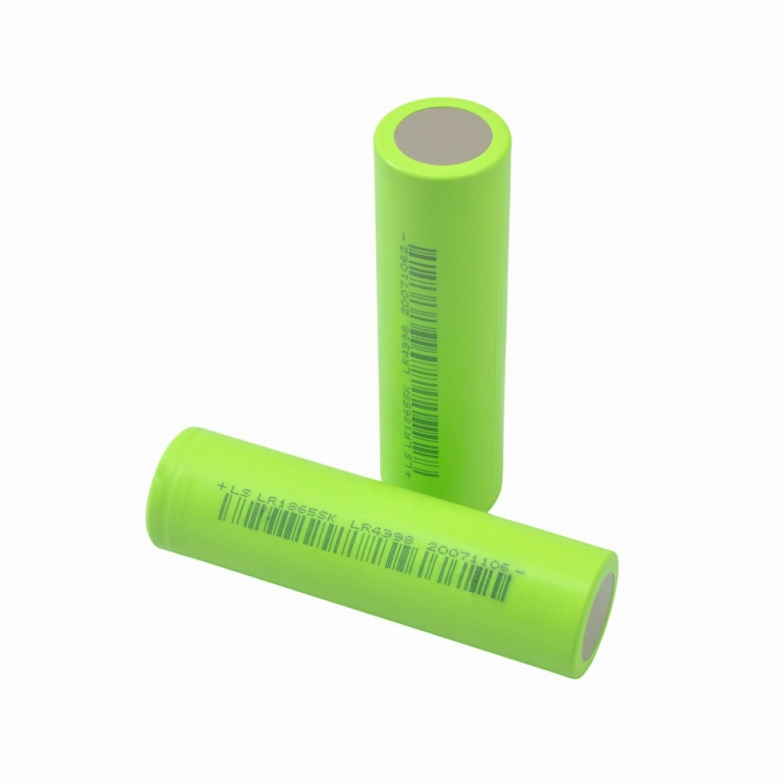Lithium polymer batteries in the common size 18650 were chosen to power the device due to their commonality.

Flat cells can also be used if the project runs into space constraints, which is unlikely.

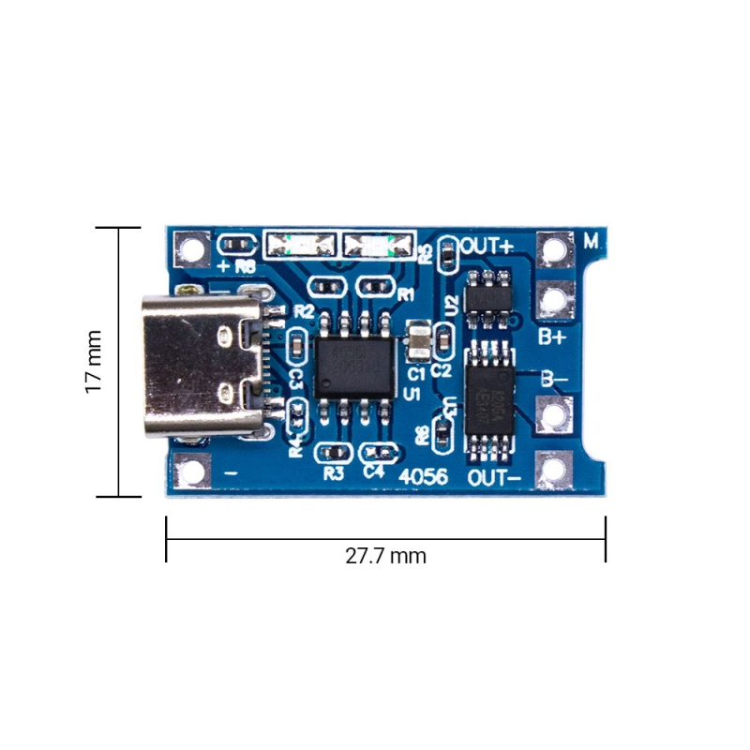Charging the battery will be done using a USB-C Li-Po battery charger module which will also provide the necessary voltage and current protections such as over-current, over-voltage and under-voltage protection.

An off the shelf, proven solution was chosen instead of developing one from scratch, saving on time and increasing reliability.

## Panel temperature sensor(s)

An interesting approach to panel temperature measurement was chosen. Instead of using analog sensors and having to deal with accuracy problems of analog circuits, noise susceptibility and most importantly and the current draw of analog sensors, the decision was made to use digital sensors.

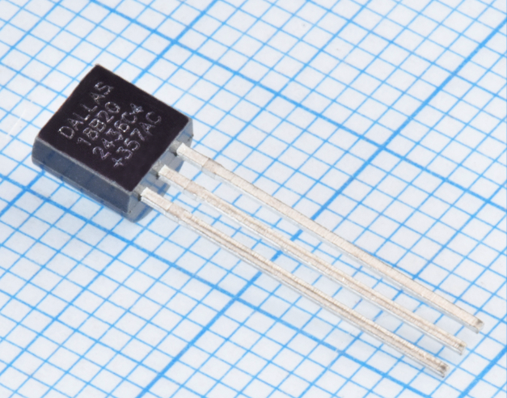A very good digital sensor that can be used with just two wires is the famous DS18B20 by Maxim semiconductor.

This sensor provides the accuracy needed for our application.

Two wire mode can be be easily implemented by connecting supply pin of the sensor to ground, this action triggers the internal logic of the sensor to draw power form the data line!

Since the power demands of the sensor is really low, this is perfectly safe and works well in industrial applications.

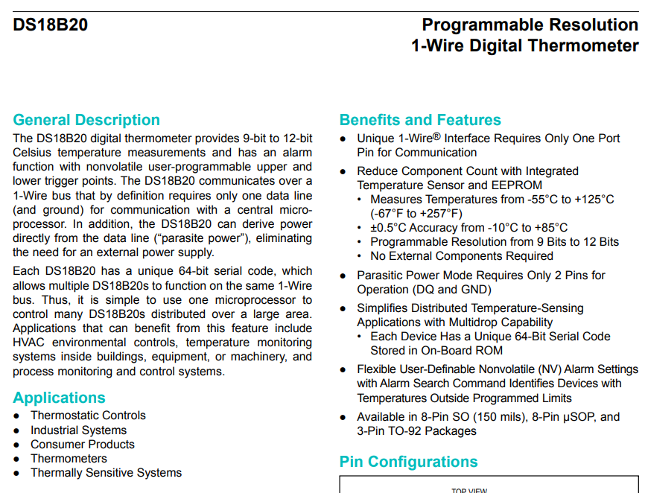

The mentioned sensor is available in weather proof probes as well.

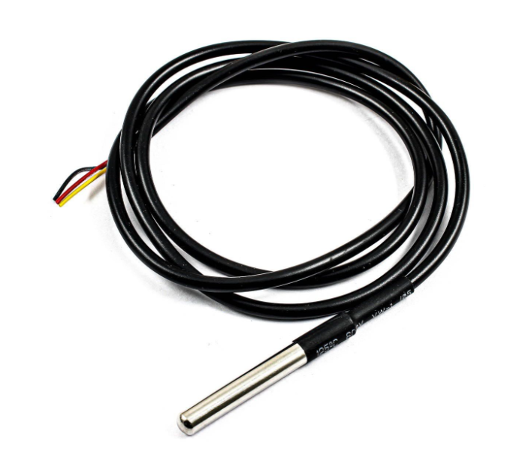

Each sensor has a unique 64-bit identification code which allows many sensors to be connected on the same bus. Both parasite power and multiple sensor capability are illustrated on the figure below.

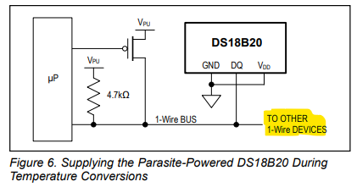

## Panel tilt angle measurement

Another important variable that commercial devices similar to the one we are building measure is panel tilt angle. Which can be measured using an accelerometer.

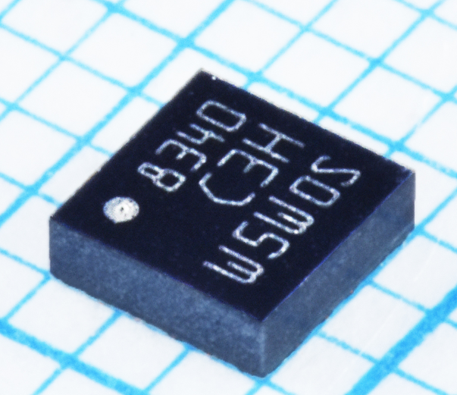Since the accuracy requirements are not very strict, a simple accelerometer by the part number **LIS3DHTR** was chosen.

By using sensor data and calculating where the gravity acceleration vector is pointing, the angle of the device can be calculated.

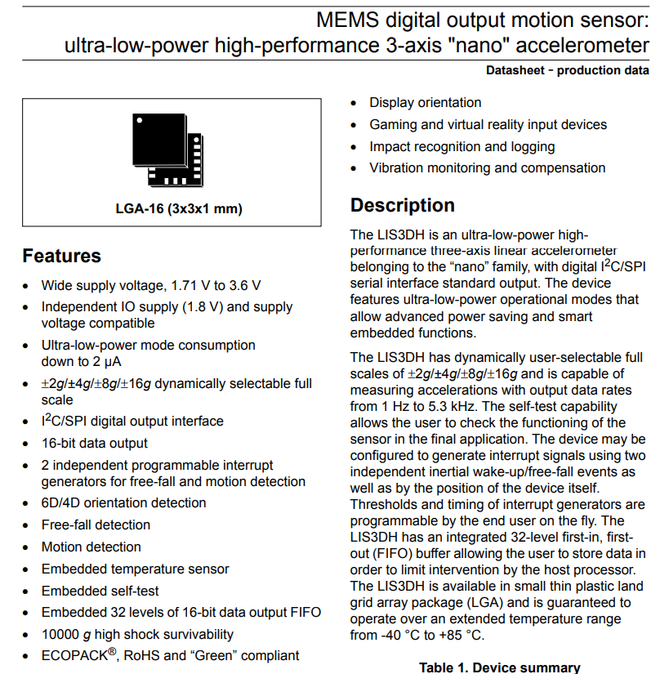

## Solar irradiance sensor

The solar irradiance sensor used in the reference product Solar-03 made by HT Instruments is an external reference solar cell that is very well characterized and tested. Solar-03 then measures the current generated by the panel and correlates that to a solar irradiance number.

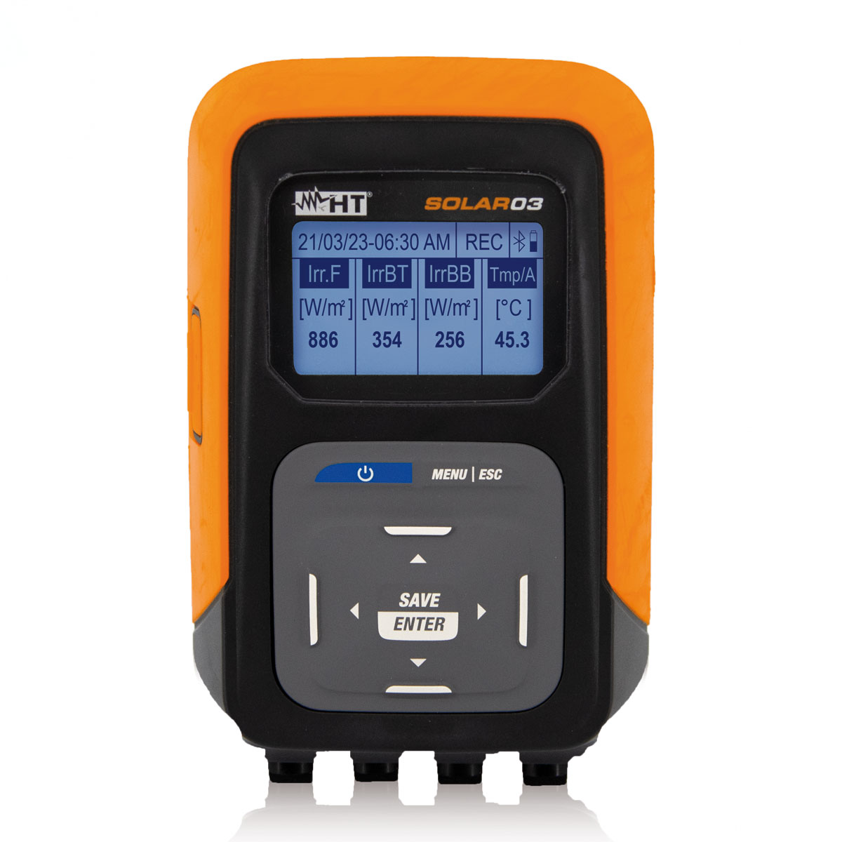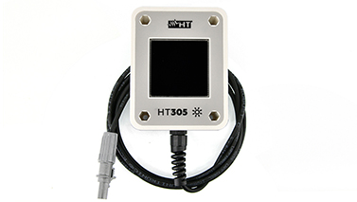

The irradiance sensor can be seen on the right which has internally stored calibration data which the Solar-03 uses to calculate the solar irradiance. The basic specs can be found in the table below.

* **Measuring range**: 100 ÷ 1400W/m2
* **Basic accuracy**: ±3.0% reading
* **Type of cell**: Monocrystalline
* **FOV angle**: >160°
* **IP rating**: IP65 according to IEC/EN60529
* **Output connector**: custom 5-pin HT connector
* **Connection cable**: approx. 2m
* **Dimensions (WxDxH)**: 111x85x28mm
* **Weight**: 240g
* **Internally stored calibration parameters**

More time seems to be required in order to choose the right sensor. This is mainly the result of few available options if we decide to go the buying route and the difficulty of molding and characterizing a reference cell by ourselves if we decide to go the DIY route.